**Challenge Name : Simple WebApp.**

Description : After facing challenges, I successfully developed a web application. However, I'm uncertain why I opted to host it on Linux

Flag Format : flag{….}

Author : Samarth Kamble

Steps to solve :

To solve the challenge we have to perform Linux commands but not common linux command.

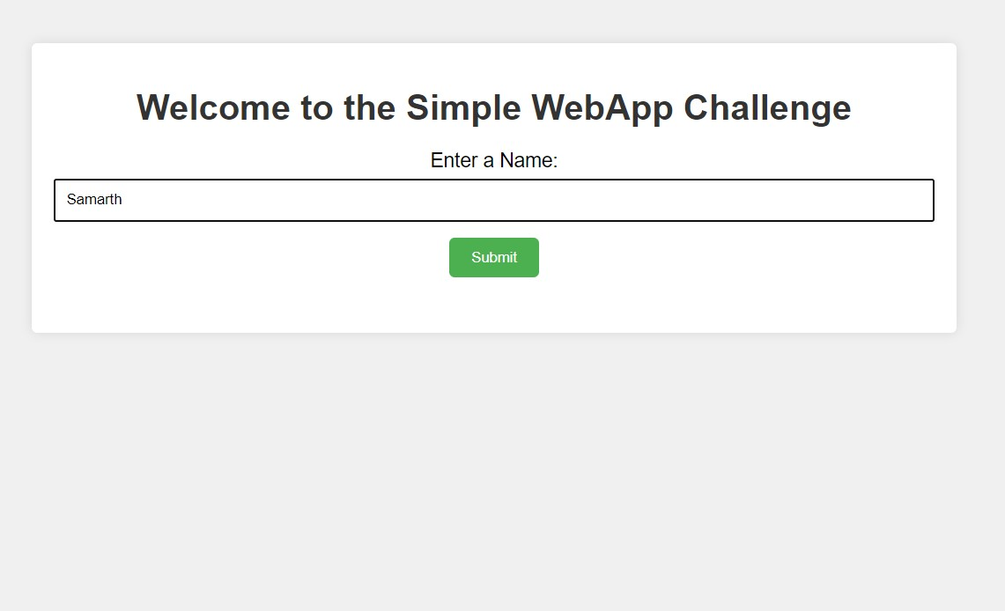

1). Lets check with whoami command.

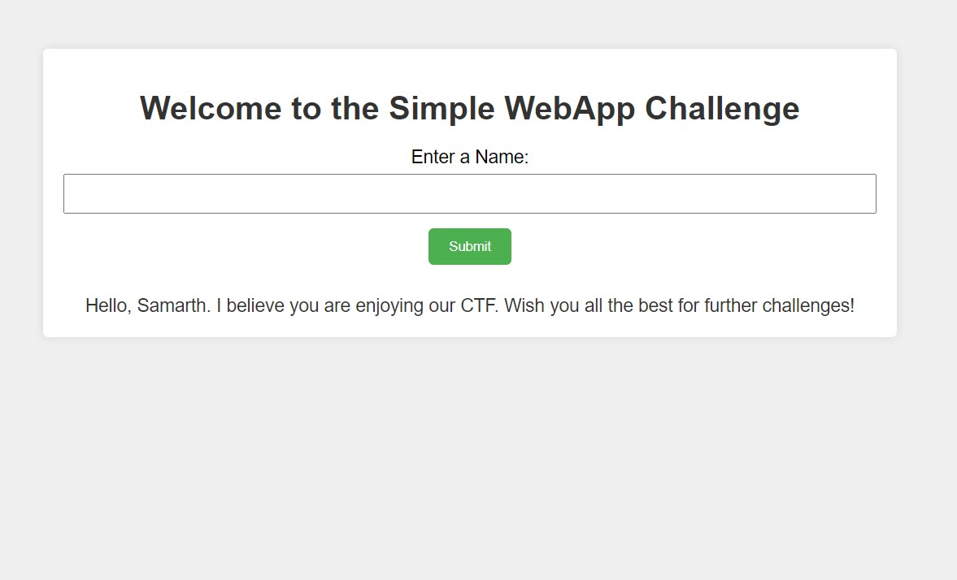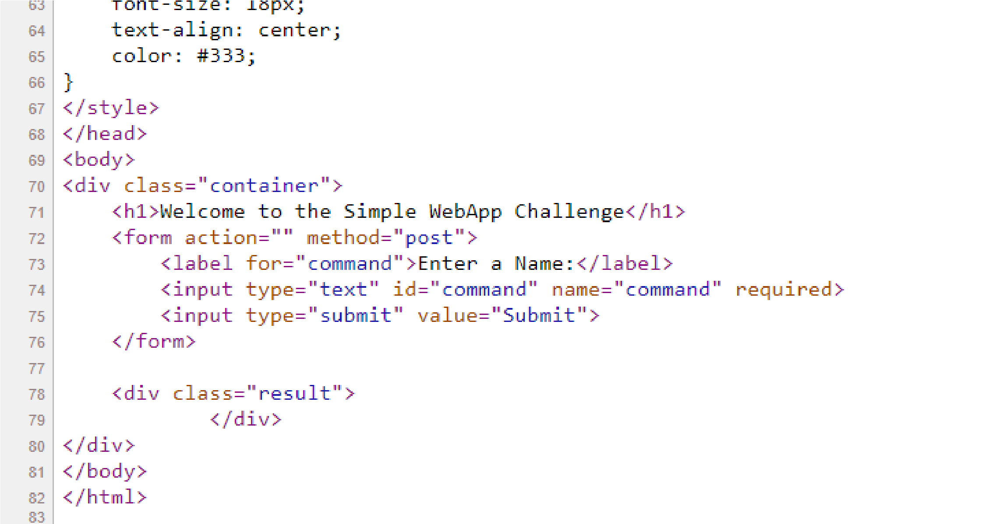

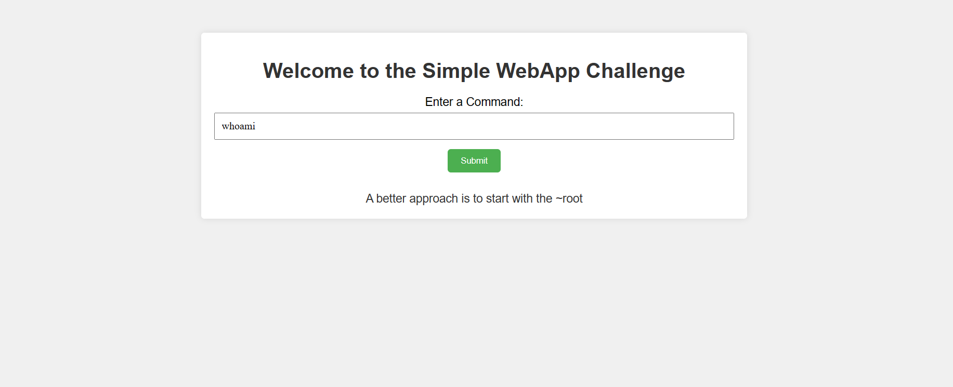

2). Lets try common ls command

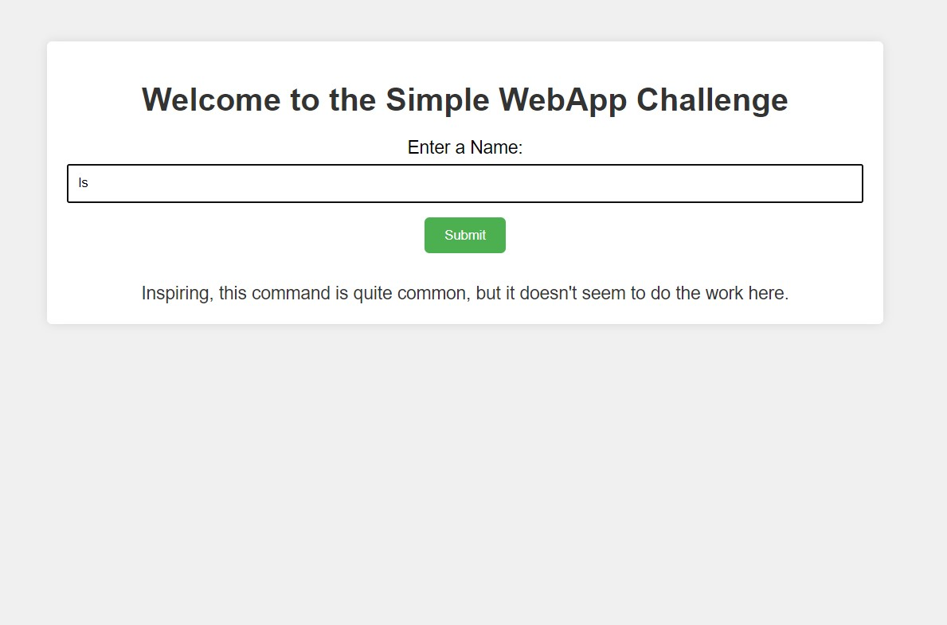

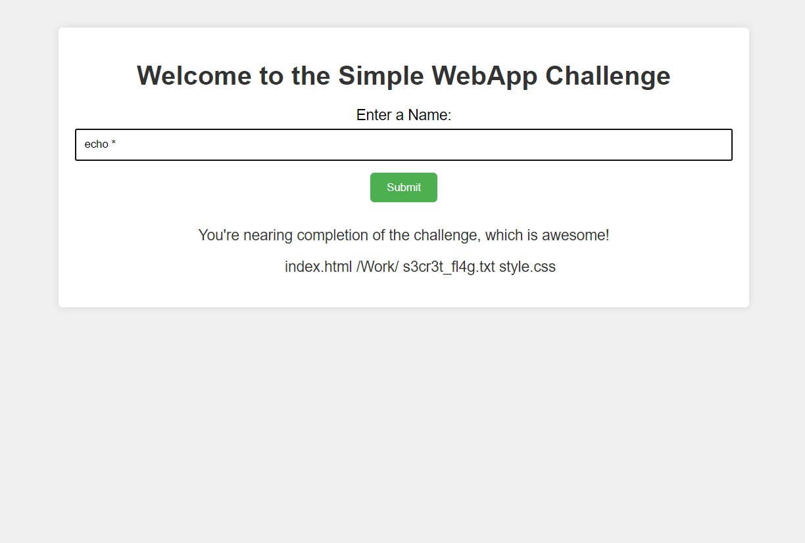

3) Using echo * command to list all files and directory

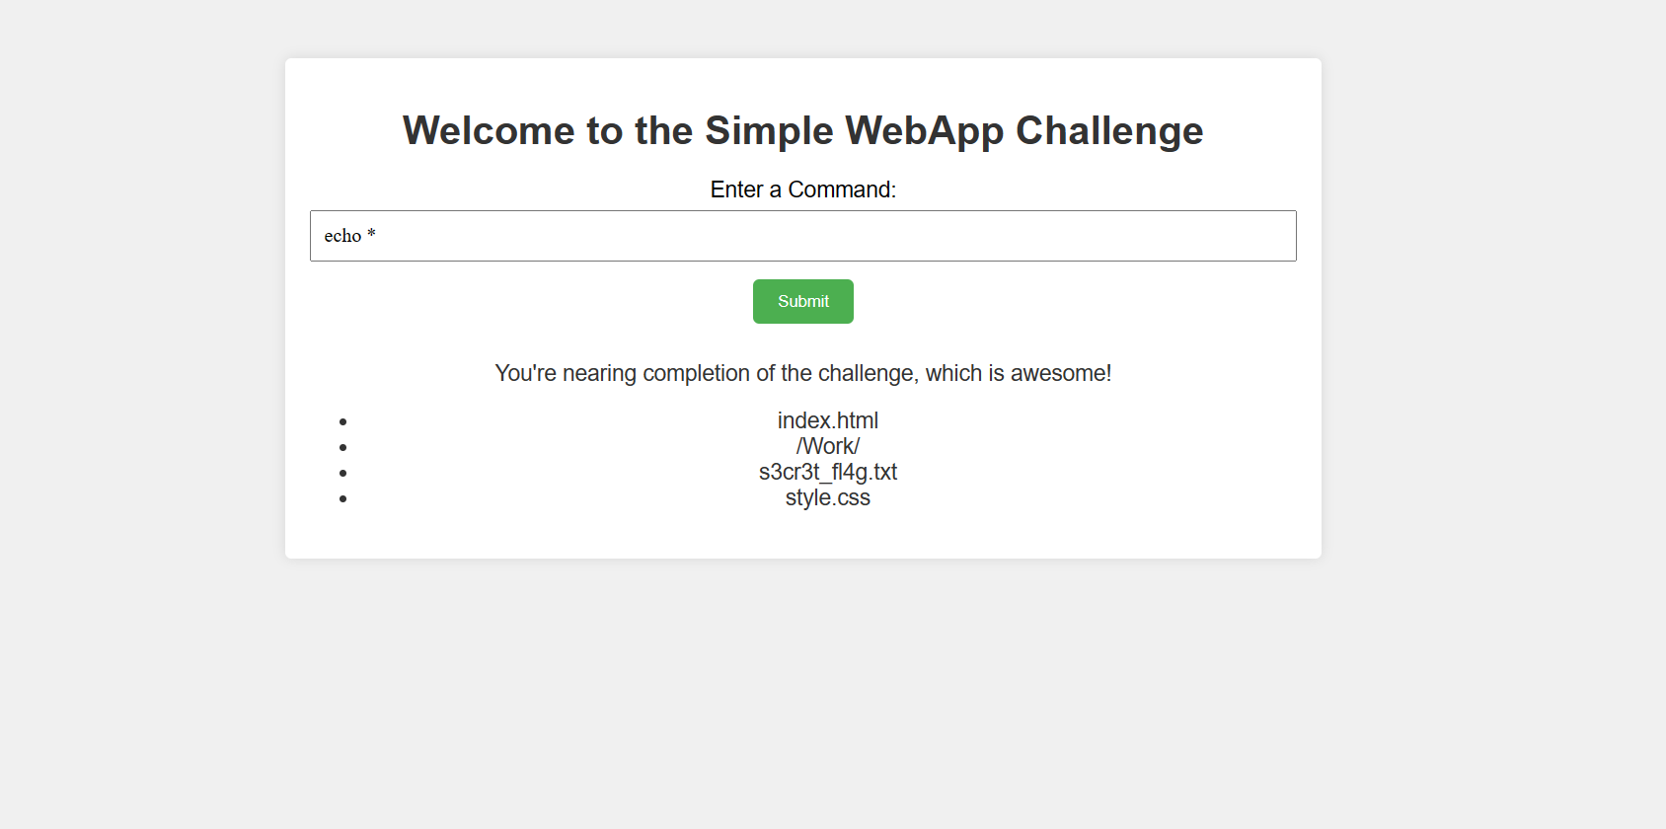

4) Use batcat to get the flag

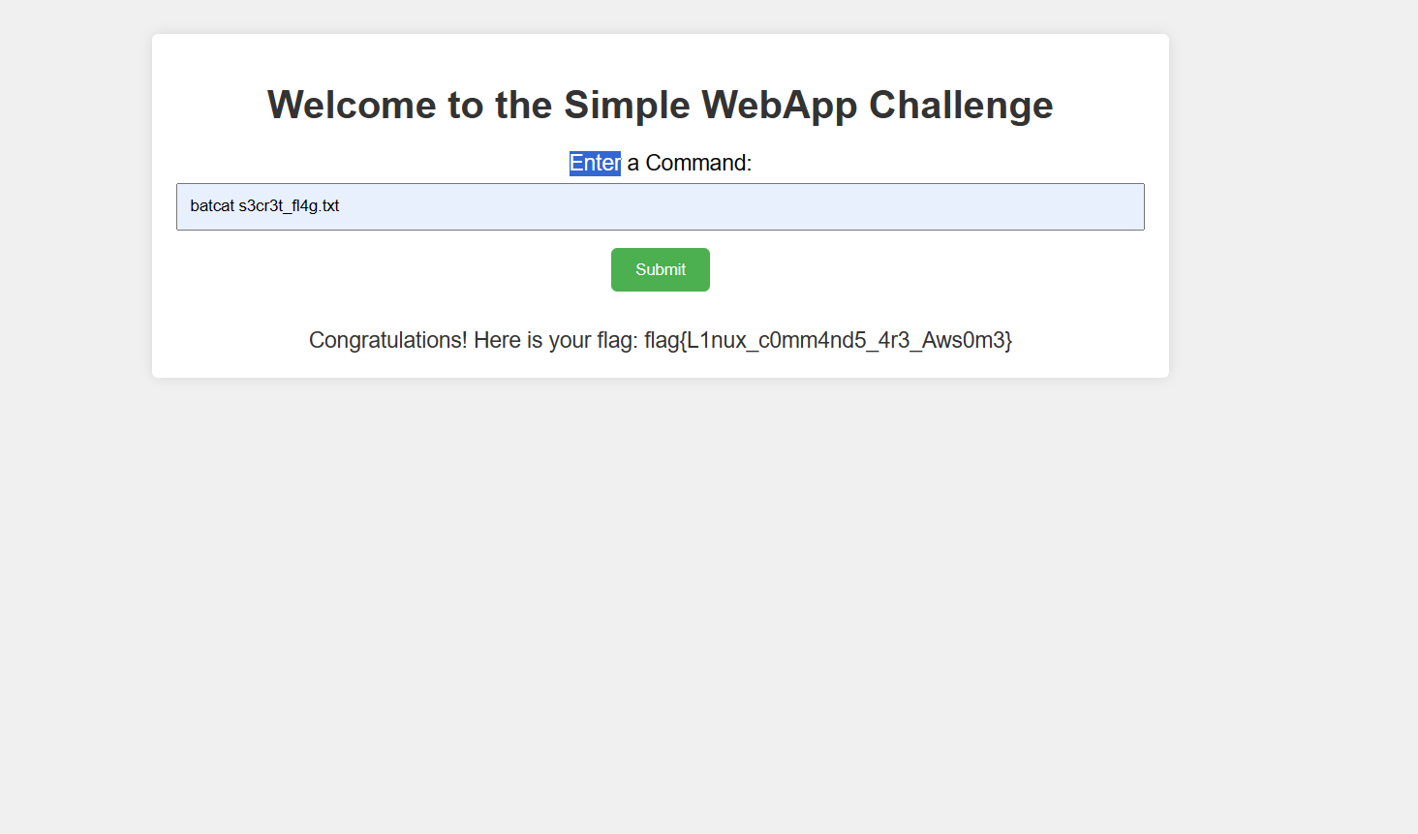

|  |
| --- |
| **Flag : flag{L1nux_c0mm4nd5_4r3_Aws0m3}** |